SIMATS ENGINEERING (SAVEETHA SCHOOL OF ENGINEERING)
Department of Computer Science and Engineering
ASSESSMENT TOOL 1 – PSEUDOCODE WRITING

Course Code: | ITA03 | Course Title: | Mobile computing
CO Assessed: | CO3 – Precision (BL3) | Assessment: | Assessment Tool 1– Pseudocode
Weightage: | 30 % of CIA | Total Marks: | 100
CO3 Statement: | Implement wireless networking and Mobile IP concepts for routing in cellular and ad hoc networks.. (BTL 3)
Student Name: | SHAIK MAHINOOR | Reg. No.: | 192311241
Section / Batch: | CSE | Date: | 24/10/2026

Code of Conduct
I K. Ramya / 192311149 certify that this submission is my original work and that I have adhered to the guidelines specified for this assessment. I understand that any violation of academic integrity rules will result in disciplinary action.
Signature of the Student: SHAIK MAHINOOR

Instructions
- Duration: 1 hour
- Answer all Questions
- Write Pseudocode in paper and upload program in GITHUB

Faculty In-charge | Course Coordinator | Head of Department
Signature: _______________ | Signature: _______________ | Signature: _______________
Date: ___________________ | Date: ___________________ | Date: ___________________

Questions
- Design a health and self-care mobile app that helps users maintain mental wellbeing with meditations and exercises. This case study talks you through the design process of creating a user- friendly mobile app. Design UI with the following requirements.
- User Login
- Register
- Health Routine Blogs
- Self-Care Blogs

- This is an intelligent job assistant that helps users find their ideal job and get to all the way to signing a contract faster and more easily. Design UI with the following requirements.
- User Login
- Register Subscription
- Personal Detail
- Resume Upload
- Choosing Job

- This is a mobile app that can help people get parking slots easily even when they travel beyond their normal routes. Design UI with the following requirements.
- UserLogin
- Register Count of Empty Parking
- Free Parking Slots Display
- Booking Parking Slots

- Design a mobile app for Online Body Fitness tips and videos for a good daily routine. Contains the following requirements.
User Login
- Register
- Fitness Blog
- Diet Planner
- Fitness Videos
- Payment and Subscription

Question 1: Health and Self-Care Mobile App

<!DOCTYPE html>
<html>
<head>
<title>MindCare App</title>
<meta name="viewport" content="width=device-width, initial-scale=1">
<style>
body {
font-family: Arial;
background: #e8f5e9;
text-align: center;
margin: 0;
}
header {
background: #2e7d32;
color: white;
padding: 20px;
}
.container {
background: white;
padding: 20px;
margin: 20px auto;
max-width: 500px;
border-radius: 12px;
}
input, button {
padding: 10px;
margin: 7px;
width: 85%;
box-sizing: border-box;
}
button {
background: #2e7d32;
color: white;
border: none;
border-radius: 5px;
cursor: pointer;
}
.blog {
background: #f1f8e9;
padding: 10px;
margin: 10px;
border-radius: 8px;
}
#message { color: #2e7d32; }
</style>
</head>
<body>

<header>
<h1>MindCare</h1>
<p>Your Mental Health and Self-Care Companion</p>
</header>

<div class="container">
<h2>User Login</h2>
<input type="email" id="loginEmail" placeholder="Email">
<input type="password" id="loginPassword" placeholder="Password">
<button onclick="login()">Login</button>

<h2>Register</h2>
<input type="text" id="name" placeholder="Full Name">
<input type="email" id="email" placeholder="Email">
<input type="password" id="password" placeholder="Password">
<button onclick="register()">Register</button>

<p id="message"></p>
</div>

<div class="container">
<h2>Health Routine Blogs</h2>
<div class="blog">
<h3>Daily Exercise</h3>
<p>Try walking, stretching, and simple exercises every day.</p>
</div>
<div class="blog">
<h3>Meditation</h3>
<p>Spend a few minutes breathing calmly and relaxing your mind.</p>
</div>
</div>

<div class="container">
<h2>Self-Care Blogs</h2>
<div class="blog">
<h3>Good Sleep</h3>
<p>Maintain a regular sleep schedule and take enough rest.</p>
</div>
<div class="blog">
<h3>Positive Habits</h3>
<p>Take breaks, enjoy hobbies, and connect with friends.</p>
</div>
</div>

<script>
function login() {
let email = document.getElementById("loginEmail").value;
let password = document.getElementById("loginPassword").value;

if (email && password) {
document.getElementById("message").innerText =
"Login Successful!";
} else {
document.getElementById("message").innerText =
"Enter email and password.";
}
}

function register() {
let name = document.getElementById("name").value;
let email = document.getElementById("email").value;
let password = document.getElementById("password").value;

if (name && email && password) {
document.getElementById("message").innerText =
"Registration Successful!";
} else {
document.getElementById("message").innerText =
"Please fill all registration fields.";
}
}
</script>

</body>
</html>

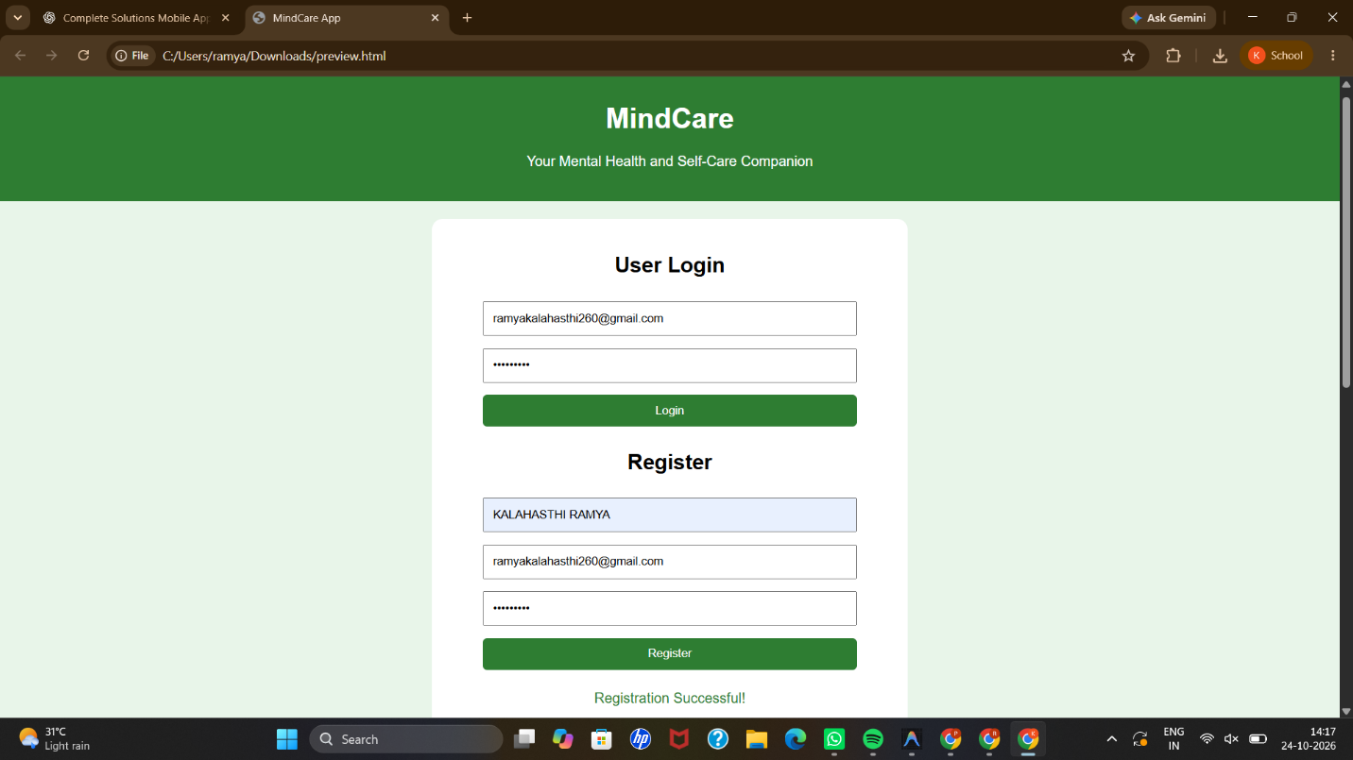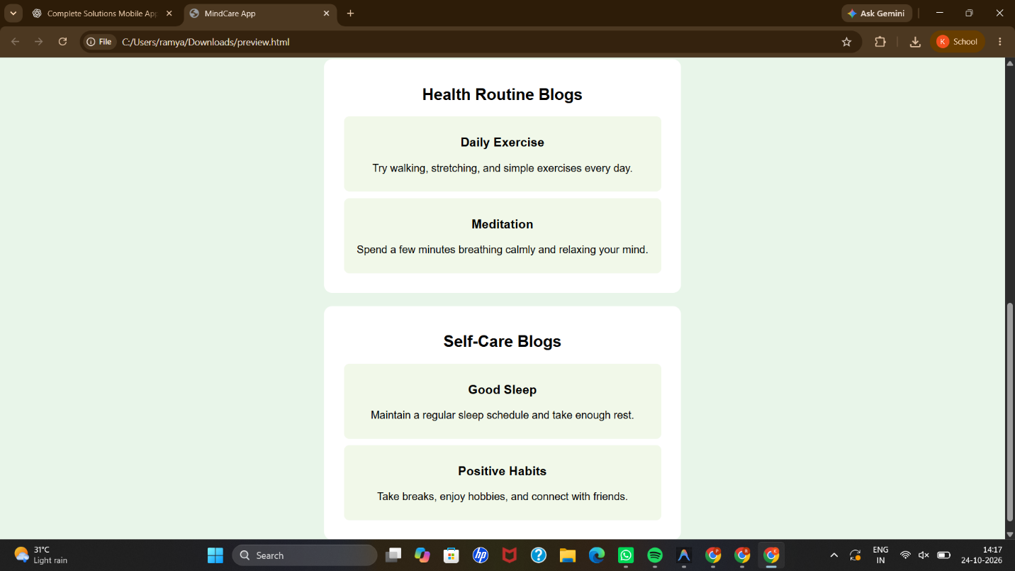

Question 2: Intelligent Job Assistant App

<!DOCTYPE html>
<html>
<head>
<title>JobAssist App</title>
<meta name="viewport" content="width=device-width, initial-scale=1">
<style>
body {
font-family: Arial;
background: #e3f2fd;
text-align: center;
margin: 0;
}
header {
background: #1565c0;
color: white;
padding: 20px;
}
.container {
background: white;
padding: 20px;
margin: 20px auto;
max-width: 500px;
border-radius: 12px;
}
input, select, button {
padding: 10px;
margin: 7px;
width: 85%;
box-sizing: border-box;
}
button {
background: #1565c0;
color: white;
border: none;
border-radius: 5px;
cursor: pointer;
}
#message { color: #1565c0; }
</style>
</head>
<body>

<header>
<h1>JobAssist</h1>
<p>Find Your Ideal Job</p>
</header>

<div class="container">
<h2>User Login</h2>
<input type="email" id="loginEmail" placeholder="Email">
<input type="password" id="loginPassword" placeholder="Password">
<button onclick="login()">Login</button>

<h2>Register</h2>
<input type="text" id="name" placeholder="Full Name">
<input type="email" id="email" placeholder="Email">
<input type="password" id="password" placeholder="Password">
<button onclick="register()">Register</button>
<p id="message"></p>
</div>

<div class="container">
<h2>Subscription</h2>
<select id="subscription">
<option>Free Plan</option>
<option>Premium Monthly Plan</option>
<option>Premium Yearly Plan</option>
</select>
<button onclick="choosePlan()">Choose Subscription</button>
<p id="planMessage"></p>
</div>

<div class="container">
<h2>Personal Details</h2>
<input type="text" id="education" placeholder="Education">
<input type="text" id="skills" placeholder="Skills">
<input type="text" id="experience" placeholder="Experience">
<button onclick="saveDetails()">Save Details</button>
<p id="detailsMessage"></p>
</div>

<div class="container">
<h2>Resume Upload</h2>
<input type="file" id="resume" accept=".pdf,.doc,.docx">
<button onclick="uploadResume()">Upload Resume</button>
<p id="resumeMessage"></p>
</div>

<div class="container">
<h2>Choose a Job</h2>
<select id="job">
<option>Web Developer</option>
<option>Software Engineer</option>
<option>Data Analyst</option>
<option>Mobile App Developer</option>
</select>
<button onclick="chooseJob()">Select Job</button>
<p id="jobMessage"></p>
</div>

<script>
function login() {
let email = document.getElementById("loginEmail").value;
let password = document.getElementById("loginPassword").value;

document.getElementById("message").innerText =
email && password ? "Login Successful!" :
"Enter email and password.";
}

function register() {
let name = document.getElementById("name").value;
let email = document.getElementById("email").value;
let password = document.getElementById("password").value;

document.getElementById("message").innerText =
name && email && password ? "Registration Successful!" :
"Fill all registration fields.";
}

function choosePlan() {
let plan = document.getElementById("subscription").value;
document.getElementById("planMessage").innerText =
"Selected: " + plan;
}

function saveDetails() {
let education = document.getElementById("education").value;
let skills = document.getElementById("skills").value;
let experience = document.getElementById("experience").value;

if (education && skills && experience) {
document.getElementById("detailsMessage").innerText =
"Personal Details Saved!";
} else {
document.getElementById("detailsMessage").innerText =
"Please fill all details.";
}
}

function uploadResume() {
let file = document.getElementById("resume").files[0];

document.getElementById("resumeMessage").innerText =
file ? "Resume Selected: " + file.name :
"Please select a resume file.";
}

function chooseJob() {
let job = document.getElementById("job").value;
document.getElementById("jobMessage").innerText =
"Selected Job: " + job;
}
</script>

</body>
</html>
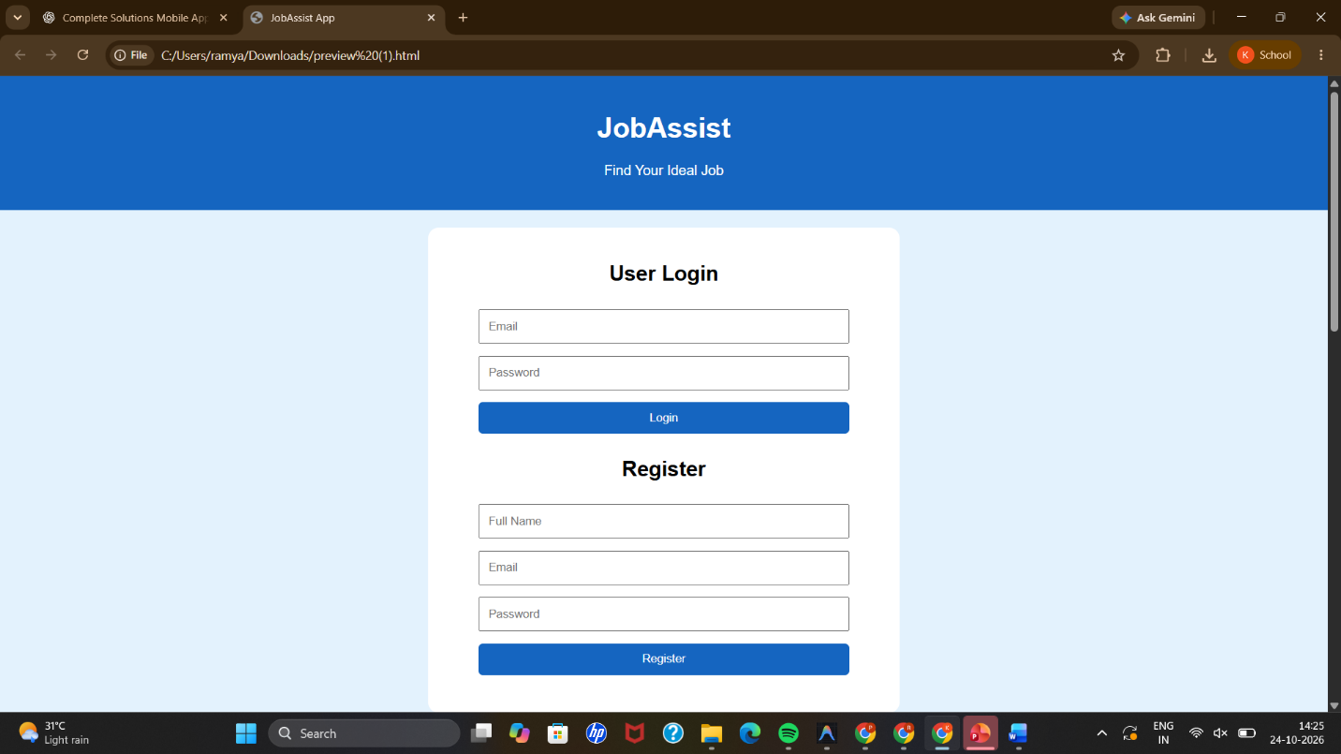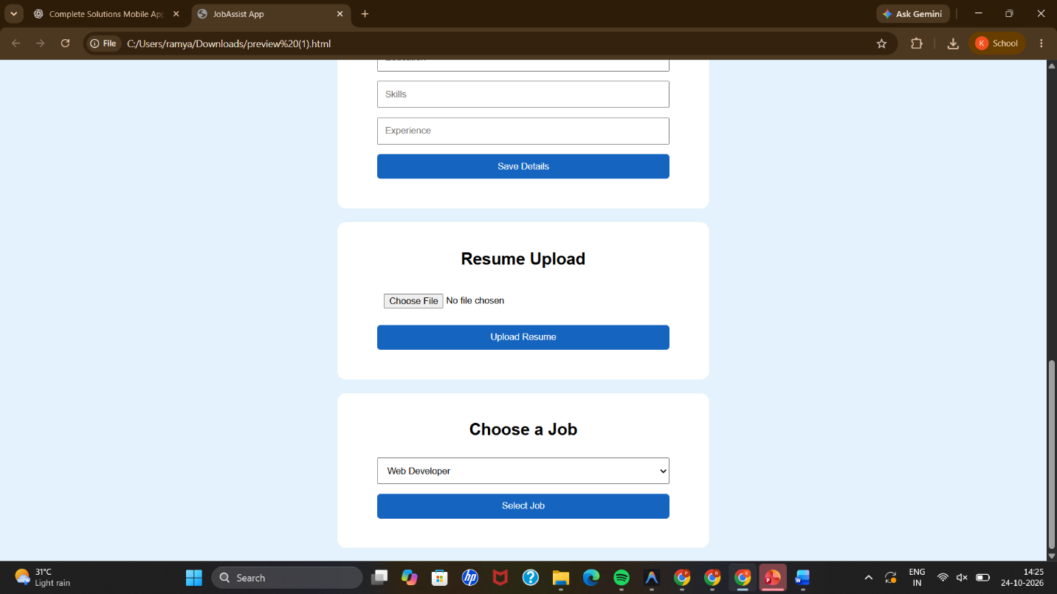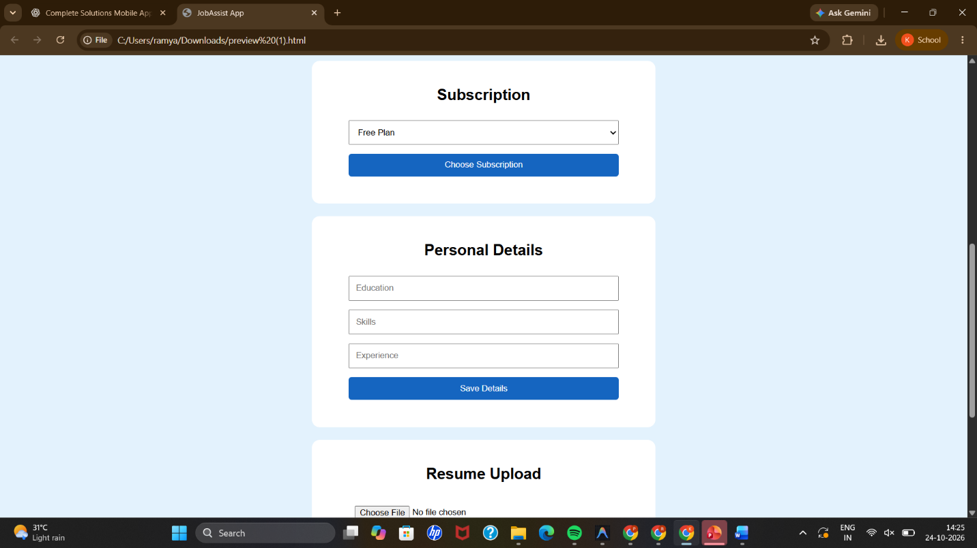

Question 3: Smart Parking Mobile App

<!DOCTYPE html>
<html>
<head>
<title>SmartPark App</title>
<meta name="viewport" content="width=device-width, initial-scale=1">
<style>
body {
font-family: Arial;
background: #e8f5e9;
text-align: center;
margin: 0;
}
header {
background: #2e7d32;
color: white;
padding: 20px;
}
.container {
background: white;
padding: 20px;
margin: 20px auto;
max-width: 500px;
border-radius: 12px;
}
input, select, button {
padding: 10px;
margin: 7px;
width: 85%;
box-sizing: border-box;
}
button {
background: #2e7d32;
color: white;
border: none;
border-radius: 5px;
cursor: pointer;
}
#message { color: #2e7d32; }
</style>
</head>
<body>

<header>
<h1>SmartPark</h1>
<p>Find and Book Parking Slots</p>
</header>

<div class="container">
<h2>User Login</h2>
<input type="email" id="loginEmail" placeholder="Email">
<input type="password" id="loginPassword" placeholder="Password">
<button onclick="login()">Login</button>

<h2>Register</h2>
<input type="text" id="name" placeholder="Full Name">
<input type="email" id="email" placeholder="Email">
<input type="password" id="password" placeholder="Password">
<button onclick="register()">Register</button>
<p id="message"></p>
</div>

<div class="container">
<h2>Find Parking Location</h2>
<select id="location" onchange="showSlots()">
<option value="Mall">Shopping Mall</option>
<option value="Hospital">City Hospital</option>
<option value="Station">Railway Station</option>
</select>
<button onclick="showSlots()">Check Empty Slots</button>
<h3 id="count"></h3>
<div id="slots"></div>
</div>

<div class="container">
<h2>Book Parking Slot</h2>
<label for="slot">Select a free slot:</label>
<select id="slot"></select>

<label for="duration">Parking Duration:</label>
<select id="duration">
<option>1 Hour</option>
<option>2 Hours</option>
<option>3 Hours</option>
<option>4 Hours</option>
</select>

<button onclick="bookSlot()">Book Slot</button>
<p id="bookingMessage"></p>
</div>

<script>
let parking = {
Mall: {
total: 5,
free: [1, 2, 3, 4, 5]
},
Hospital: {
total: 4,
free: [1, 2, 3, 4]
},
Station: {
total: 6,
free: [1, 2, 3, 4, 5, 6]
}
};

function login() {
let email = document.getElementById("loginEmail").value;
let password = document.getElementById("loginPassword").value;

document.getElementById("message").innerText =
email && password ? "Login Successful!" :
"Enter email and password.";
}

function register() {
let name = document.getElementById("name").value;
let email = document.getElementById("email").value;
let password = document.getElementById("password").value;

document.getElementById("message").innerText =
name && email && password ? "Registration Successful!" :
"Fill all registration fields.";
}

function showSlots() {
let location = document.getElementById("location").value;
let free = parking[location].free;

document.getElementById("count").innerText =
"Empty Parking Slots: " + free.length;

document.getElementById("slots").innerText =
free.length > 0 ? "Free Slots: " + free.join(", ") :
"No Parking Slots Available";

let select = document.getElementById("slot");
select.innerHTML = "";

free.forEach(function(number) {
let option = document.createElement("option");
option.value = number;
option.text = "Slot " + number;
select.add(option);
});
}

function bookSlot() {
let location = document.getElementById("location").value;
let slot = Number(document.getElementById("slot").value);
let duration = document.getElementById("duration").value;
let free = parking[location].free;

if (free.length === 0 || !free.includes(slot)) {
document.getElementById("bookingMessage").innerText =
"No free slot available. Select another location.";
showSlots();
return;
}

parking[location].free = free.filter(function(number) {
return number !== slot;
});

document.getElementById("bookingMessage").innerText =
"Slot " + slot + " booked at " + location +
" for " + duration + "!";

showSlots();
}

showSlots();
</script>

</body>
</html>
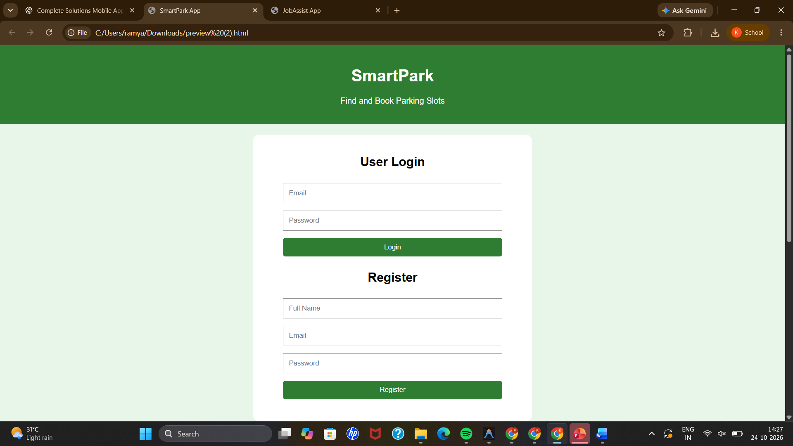
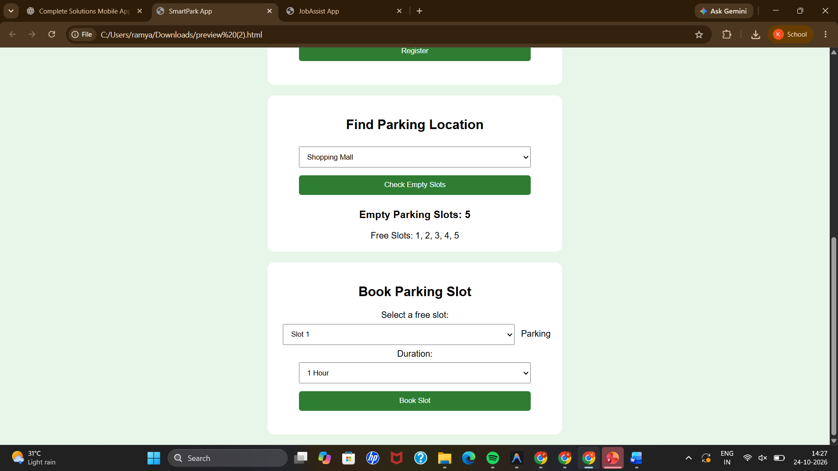

Question 4: Online Body Fitness Mobile App

<!DOCTYPE html>
<html>
<head>
<title>FitLife App</title>
<meta name="viewport" content="width=device-width, initial-scale=1">
<style>
body {
font-family: Arial;
background: #fff3e0;
text-align: center;
margin: 0;
}
header {
background: #e65100;
color: white;
padding: 20px;
}
.container {
background: white;
padding: 20px;
margin: 20px auto;
max-width: 500px;
border-radius: 12px;
}
input, select, button {
padding: 10px;
margin: 7px;
width: 85%;
box-sizing: border-box;
}
button {
background: #e65100;
color: white;
border: none;
border-radius: 5px;
cursor: pointer;
}
.blog {
background: #fff3e0;
padding: 10px;
margin: 10px;
border-radius: 8px;
}
#message { color: #e65100; }
</style>
</head>
<body>

<header>
<h1>FitLife</h1>
<p>Your Daily Fitness Companion</p>
</header>

<div class="container">
<h2>User Login</h2>
<input type="email" id="loginEmail" placeholder="Email">
<input type="password" id="loginPassword" placeholder="Password">
<button onclick="login()">Login</button>

<h2>Register</h2>
<input type="text" id="name" placeholder="Full Name">
<input type="email" id="email" placeholder="Email">
<input type="password" id="password" placeholder="Password">
<button onclick="register()">Register</button>
<p id="message"></p>
</div>

<div class="container">
<h2>Fitness Blog</h2>
<div class="blog">
<h3>Daily Exercise</h3>
<p>Exercise regularly to improve strength and fitness.</p>
</div>
<div class="blog">
<h3>Warm-Up</h3>
<p>Warm up before exercising to prepare your body.</p>
</div>
</div>

<div class="container">
<h2>Diet Planner</h2>
<label for="goal">Choose Fitness Goal:</label>
<select id="goal">
<option>Balanced Diet</option>
<option>Muscle Building</option>
<option>Healthy Eating</option>
</select>
<button onclick="dietPlan()">Generate Diet Plan</button>
<p id="diet"></p>
</div>

<div class="container">
<h2>Fitness Videos</h2>
<select id="video">
<option>Warm-Up Exercises</option>
<option>Yoga Exercises</option>
<option>Cardio Workout</option>
<option>Strength Training</option>
</select>
<button onclick="playVideo()">Select Video</button>
<p id="videoMessage"></p>
</div>

<div class="container">
<h2>Payment and Subscription</h2>
<label for="plan">Choose Subscription:</label>
<select id="plan">
<option value="199">Monthly Plan - Rs. 199</option>
<option value="1499">Yearly Plan - Rs. 1499</option>
</select>
<button onclick="subscribe()">Choose Plan</button>
<p id="paymentMessage"></p>
</div>

<script>
function login() {
let email = document.getElementById("loginEmail").value;
let password = document.getElementById("loginPassword").value;

document.getElementById("message").innerText =
email && password ? "Login Successful!" :
"Enter email and password.";
}

function register() {
let name = document.getElementById("name").value;
let email = document.getElementById("email").value;
let password = document.getElementById("password").value;

document.getElementById("message").innerText =
name && email && password ? "Registration Successful!" :
"Fill all registration fields.";
}

function dietPlan() {
let goal = document.getElementById("goal").value;

document.getElementById("diet").innerText =
"Your selected goal is " + goal +
". Sample plan: breakfast with oats and fruit, " +
"lunch with vegetables and grains, and a balanced dinner.";
}

function playVideo() {
let video = document.getElementById("video").value;

document.getElementById("videoMessage").innerText =
"Selected Fitness Video: " + video;
}

function subscribe() {
let amount = document.getElementById("plan").value;

document.getElementById("paymentMessage").innerText =
"Selected subscription amount: Rs. " + amount +
". Connect a payment gateway to complete real payment.";
}
</script>

</body>
</html>

